**Focus keyword**: **Benzonatate and Mucinex**

**Meta Title:**– **Benzonatate and Mucinex** |vigoursoul

**Meta Description:** Benzonatate and Mucinex are two medications used to treat chest congestion. Benzonatate is a cough suppressant and Mucinex is an expectorant.

**Feature Image:**

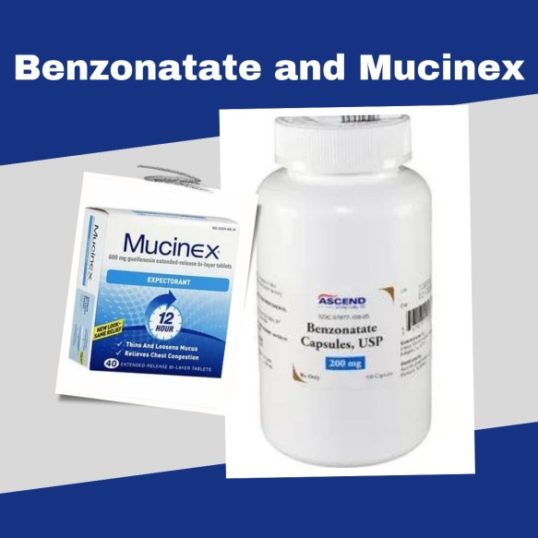

**Benzonatate and Mucinex**

Both **benzonatate and mucinex** are medications used to treat symptoms of upper respiratory illnesses such as the common cold, bronchitis, and sinusitis. Benzonatate is a type of cough suppressant that works to relieve chest congestion and reduce coughing, while Mucinex is a combination of two medications – guaifenesin and pseudoephedrine – which helps to loosen mucus and reduce sinus pressure.

While both medications can be used to treat the same symptoms, it's important to note that benzonatate is not recommended for use in children under 10 years old, while Mucinex is approved for use in children as young as four years old.

In 1958, benzonatate received medical use authorization in the US. It is accessible as a generic drug. There are few products available globally. With more over 3 million prescriptions written in 2020, it was the 157th most widely prescribed drug in the country. Since at least 1933, guaifenesin has been utilized in medicine.

**Mucinex** is sold over the counter and as a generic drug. With more than 800,000 prescriptions written in 2020, it was the 324th most often prescribed drug in the country.

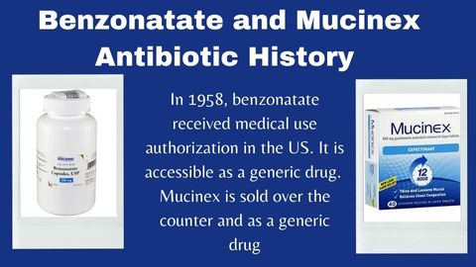

**Can You Take Mucinex and Benzonatate?**

Yes, you can take both **benzonatate and mucinex**. However, it is important to talk to your doctor before taking any new medications to ensure that the combination is appropriate for your condition. It is also important to take both medications as directed by your doctor or pharmacist.

It is important to talk to your doctor or pharmacist about any potential interactions between **benzonatate and Mucinex** before taking both medications together. Your doctor or pharmacist can help you determine the best course of treatment for your upper respiratory illness and if taking both medications together is appropriate. It is also important to take both medications as directed to ensure that you receive the full benefit of the medication.

**Benzonatate and Mucinex Night Time**

It is not recommended to take both **benzonatate and Mucinex** Night Time (a combination of acetaminophen, diphen hydramine, and phenyl phrine) together. The combination of active ingredients in Mucinex Night Time may cause drowsiness, dizziness, and even confusion when taken with benzonatate. If you are considering taking both medications, talk to your doctor or pharmacist to determine the best course of action for your symptoms.

**Benzonatate and Mucinex DM Together:**

Mucinex DM and benzonatate did not interact in any way. This does not imply that there are no interactions, though. Always get advice from your doctor.

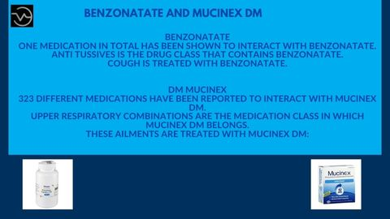

**Benzonatate**

One medication in total has been shown to interact with benzonatate.

Anti tussives is the drug class that contains benzonatate.

Cough is treated with benzonatate.

**DM Mucinex**

323 different medications have been reported to interact with Mucinex DM.

Upper respiratory combinations are the medication class in which Mucinex dm belongs.

These ailments are treated with mucinex dm:

* Cough
* Expectoration

You can take **benzonatate and Mucinex** DM (a combination of guaifenesin and dextromethorphan) together. Before taking any new medications, it is important to talk to your doctor or pharmacist to ensure that the combination is appropriate for your condition. It is also important to take both medications as directed.

**Benzonatate and Mucinex 1200 mg:**

No, it is not recommended to take **benzonatate and Mucinex** 1200 mg (guaifenesin) together. Taking two medications with the same active ingredient can result in an overdose, which could be dangerous. Before taking any new medications, it is important to talk to your doctor or pharmacist to ensure that the combination is appropriate for your condition.

**Benzonatate 100 mg and Mucinex DM:**

Yes, you can take benzonatate 100 mg and Mucinex DM (a combination of guaifenesin and dextromethorphan) together. Before taking any new medications, it is important to talk to your doctor or pharmacist to ensure that the combination is appropriate for your condition. It is also important to take both medications as directed.

**Benzonatate and Mucinex Fast Max**

Yes, you can take **benzonatate and Mucinex** Fast Max (a combination of acetaminophen, phenylephrine, and dextromethorphan) together. Before taking any new medications, it is important to talk to your doctor or pharmacist to ensure that the combination is appropriate for your condition. It is also important to take both medications as directed.

**Benzonatate and Mucinex Drug Interaction**

Yes, there is a potential for a drug interaction between **benzonatate and Mucinex**. Taking both medications together can increase the risk of side effects, such as drowsiness, dizziness, and confusion. It is important to talk to your doctor or pharmacist before taking any new medications to ensure that the combination is safe and appropriate for your condition.

**Benzonatate and Mucinex Expectorant**

Yes, you can take **benzonatate and Mucinex** Expectorant (a combination of guaifenesin and pseudoephedrine) together. Before taking any new medications, it is important to talk to your doctor or pharmacist to ensure that the combination is appropriate for your condition. It is also important to take both medications as directed.

**Benzonatate and Mucinex Sinus Max**

Yes, you can take **benzonatate and Mucinex** Sinus Max (a combination of acetaminophen, guaifenesin, phenylephrine, and pseudoephedrine) together. Before taking any new medications, it is important to talk to your doctor or pharmacist to ensure that the combination is appropriate for your condition. It is also important to take both medications as directed.

**Benzonatate and Mucinex with Tylenol**

Yes, you can take **benzonatate and Mucinex** with Tylenol (a combination of acetaminophen, guaifenesin, and dextromethorphan) together. Before taking any new medications, it is important to talk to your doctor or pharmacist to ensure that the combination is appropriate for your condition. It is also important to take both medications as directed.

**Advantages and Side Effects**

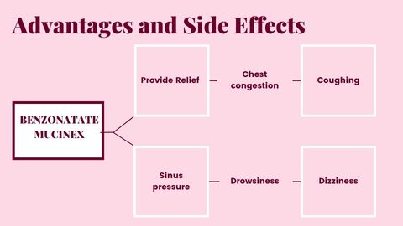

The advantage of taking both **benzonatate and Mucinex** together is that they can provide relief from common upper respiratory symptoms such as chest congestion, coughing, and sinus pressure. Additionally, both medications can help to thin mucus and reduce inflammation in the respiratory tract, making it easier to breathe. Taking both medications together can also increase the effectiveness of each, providing better relief from symptoms.

The most common side effects of taking **benzonatate and Mucinex** together are drowsiness, dizziness, and confusion. It is important to talk to your doctor or pharmacist before taking any new medications, to ensure that the combination is appropriate for your condition. Additionally, it is important to take both medications as directed to ensure that you receive the full benefit of the medication.

**Benzonatate and Mucinex-FAQS**

**What are benzonatate and Mucinex used for?**

**Benzonatate and Mucinex** are both medications used to treat symptoms of upper respiratory illnesses such as the common cold, bronchitis, and sinusitis. Benzonatate is a type of cough suppressant that works to relieve chest congestion and reduce coughing, while Mucinex is a combination of two medications – guaifenesin and pseudoephedrine – which helps to loosen mucus and reduce sinus pressure.

**Can I take benzonatate and Mucinex together?**

Yes, you can take both benzonatate and Mucinex together. However, it is important to talk to your doctor before taking any new medications to ensure that the combination is appropriate for your condition. It is also important to take both medications as directed by your doctor or pharmacist.

**Can take both benzonatate and Mucinex Night?**

No, it is not recommended to take both **benzonatate and Mucinex** Night Time (a combination of acetaminophen, diphen hydramine, and phenylephrine) together. The combination of active ingredients in Mucinex Night Time may cause drowsiness, dizziness, and even confusion when taken with benzonatate. If you are considering taking both medications, talk to your doctor or pharmacist to determine the best course of action for your symptoms.

**Can I take benzonatate 100 mg and Mucinex dm together?**

Yes, you can take benzonatate 100 mg and Mucinex DM (a combination of guaifenesin and dextromethorphan) together. Before taking any new medications, it is important to talk to your doctor or pharmacist to ensure that the combination is appropriate for your condition. It is also important to take both medications as directed.

**Are there any drug interactions between benzonatate and Mucinex?**

Yes, there is a potential for a drug interaction between **benzonatate and Mucinex**. Taking both medications together can increase the risk of side effects, such as drowsiness, dizziness, and confusion. It is important to talk

**Conclusion**

Conclusion Taking **benzonatate and Mucinex** together can provide relief from common upper respiratory symptoms, such as chest congestion, coughing, and sinus pressure. However, it is important to talk to your doctor or pharmacist before taking any new medications, to ensure that the combination is appropriate for your condition. Additionally, it is important to take both medications as directed to ensure that you receive the full benefit of the medication.